Social share buttons

### A MINI PROJECT REPORT

#### Submitted by: Bhuvesh Mittal (2210991450)

#### Group/Team No: G5/T5

**Bhupesh Relan (2210991447)**

**Bhuvan Kumar (2210991448)**

**Bhuvesh Kumar (2210991449)**

**Bhuvesh Mittal (2210991450)**

#### in partial fulfillment for the award of the degree of

## BACHELEOR OF ENGINEERING

***in***

COMPUTER SCIENCE & ENGINEERING



**CHITKARA UNIVERSITY**

**CHANDIGARH-PATIALA NATIONAL HIGHWAY**

**RAJPURA (PATIALA) PUNJAB-140401 (INDIA)**

##### MAY 2023

###### TABLE OF CONTENTS

|  |  |  |
| --- | --- | --- |
| Sr.no | Section | Page no |
| 1. | INTRODUCTION | 3 |
| 2. | **PROBLEM STATEMENT** | 4 |
| 3. | TECHNICAL DETAILS | 5 |
| 4. | PROJECT ADVANTAGES AND KEY FEATURES | 7 |
| 5. | RESULTS | 8 |
| 6. | CONCLUSION | 11 |
| 7. | REFERENCES /LINKS USED | 12 |
|  |  |  |

**INTRODUCTION**

Here are some key points to introduce social share buttons:

Social share buttons are a set of clickable icons or buttons placed on web pages, blog posts, or other digital content that allow users to easily share that content on social media platforms.

**PROBLEM STATEMENT**

In this project, we will take up the challenge of writing JavaScript code that will allow us to add social share buttons to static sites. While we can do this by incorporating HTML elements or images in the site’s template, using JavaScript allows us to add the share buttons dynamically.

**TECHNICAL DETAILS**

**USE OF HTML**

HTML can be used to create the content of a social share buttons, as well as provide the structure and layout of the web page. Here are some key points why we use HTML in social share buttons:

1.Content: HTML can be used to create the content of the webpages, such as text, images, or links.

2.Structure: HTML can be used to define the structure and layout of the buttons, different pages, such as its size, position, and background colour.

3.Customization: HTML can be customized with CSS to match the look and feel of the application, including the font, colour, and layout of the pages.

4.Responsiveness: HTML can be used to create responsive buttons that adapt different screen sizes and devices, ensuring that the button is legible and visually appealing on all devices.

5.Accessibility: HTML can be used to ensure that the website is accessible to all users, including with disabilities. For e.g., HTML can be used to provide alternative text for images or to use semantic HTML to make the button more understandable for screen readers.

**CONTINUED...**

**USE OF CSS**

CSS can be used to style the appearance and behavior of social share buttons in web applications. Here are some ways CSS can be used in:

1. Positioning: CSS can be used to position share buttons on the screen, such as at the top or bottom of the screen. This can be achieved using the CSS position property and the top, bottom, left, or right properties.
2. Styling: CSS can be used to style the appearance of webpages, such as the background colour, font, and size of the text, and the border and box-shadow properties of the notification container.
3. Animation: CSS animations can be used to add visual effects to buttons, such as fading in and out or sliding up and down. This can be achieved using the CSS animation property and the key frames rule.
4. Responsive design: CSS can be used to make buttons responsive, so they adapt to different screen sizes and devices. This can be achieved using media queries to define different styles for different screen sizes.
5. Customization: CSS can be used to customize buttons to match the look and feel of the application, using the application's colour scheme and branding.

**PROJECT ADVANTAGES AND KEY FEATURES**

Some of the key features of social share buttons include:

1. Social share buttons are designed to work with popular social media platforms
2. Social share buttons are typically very easy to use.
3. Social share buttons can be customized to fit the design and branding of a website or blog
4. They are designed to be responsive and work well on smaller screens.
5. Social share buttons help promote social engagement and increase the reach of content.

**RESULTS**

**Home Page: -**

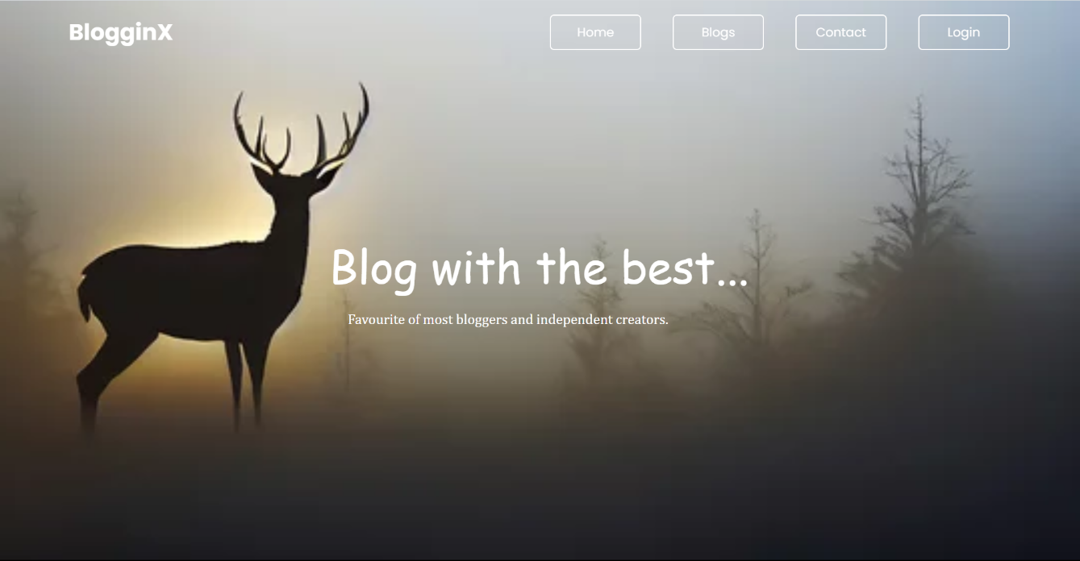

**Blog page: -**



**Contact page: -**

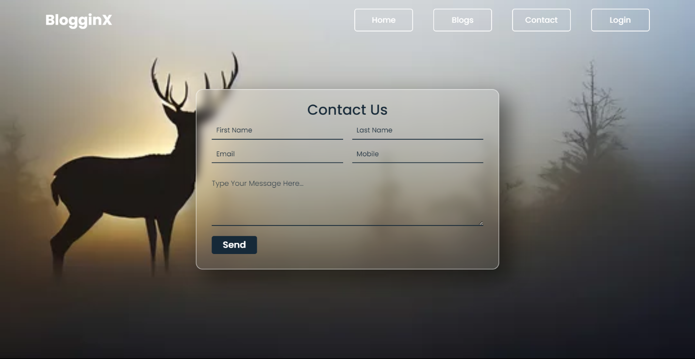

**Login page: -**

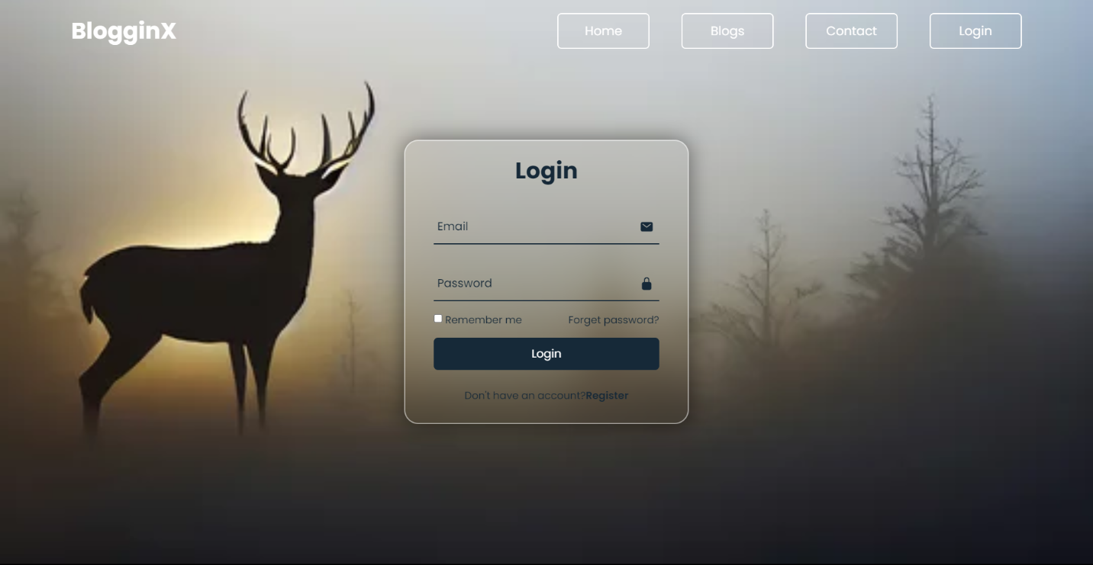

**Code Snippet: -**

**Home page –**

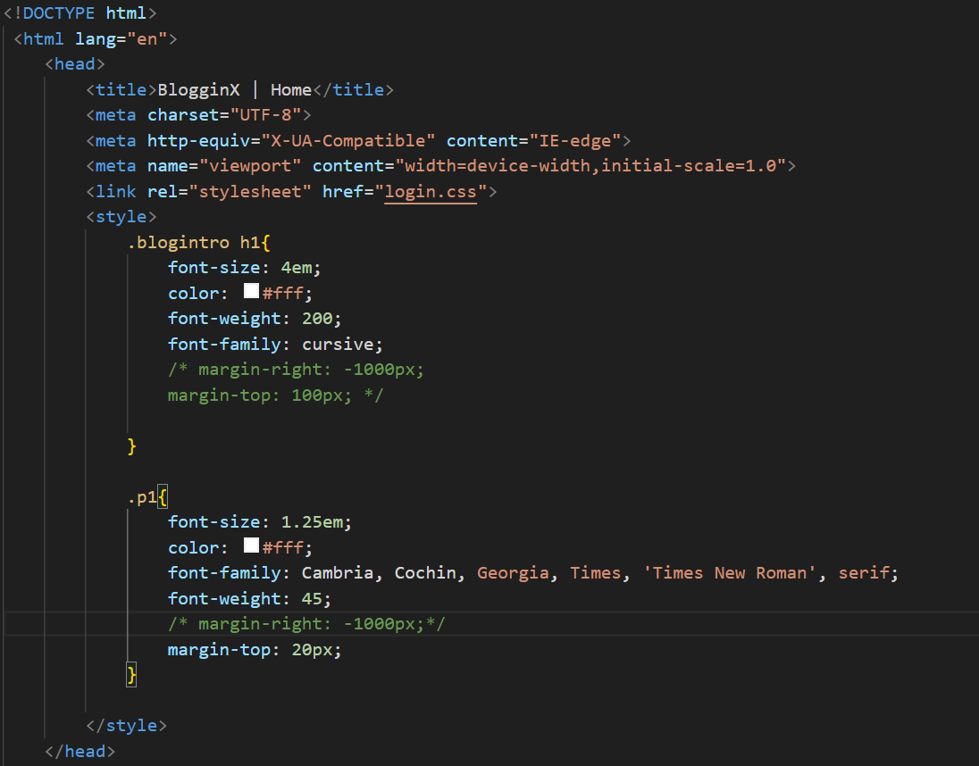

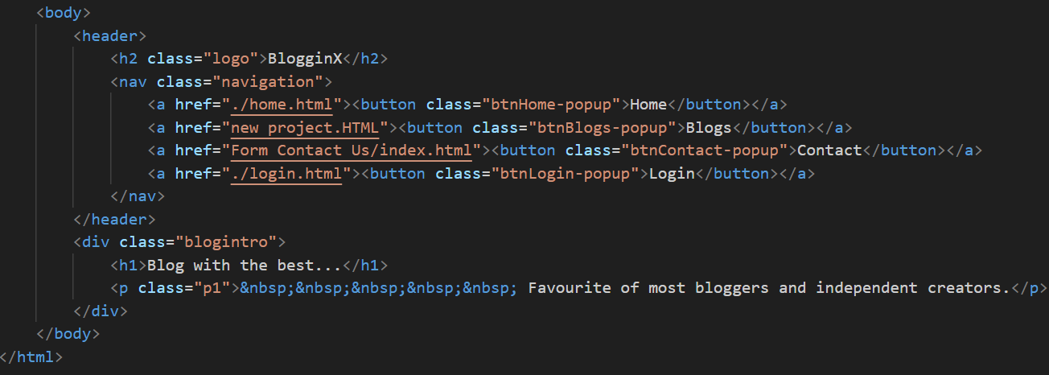

**Blog page –**

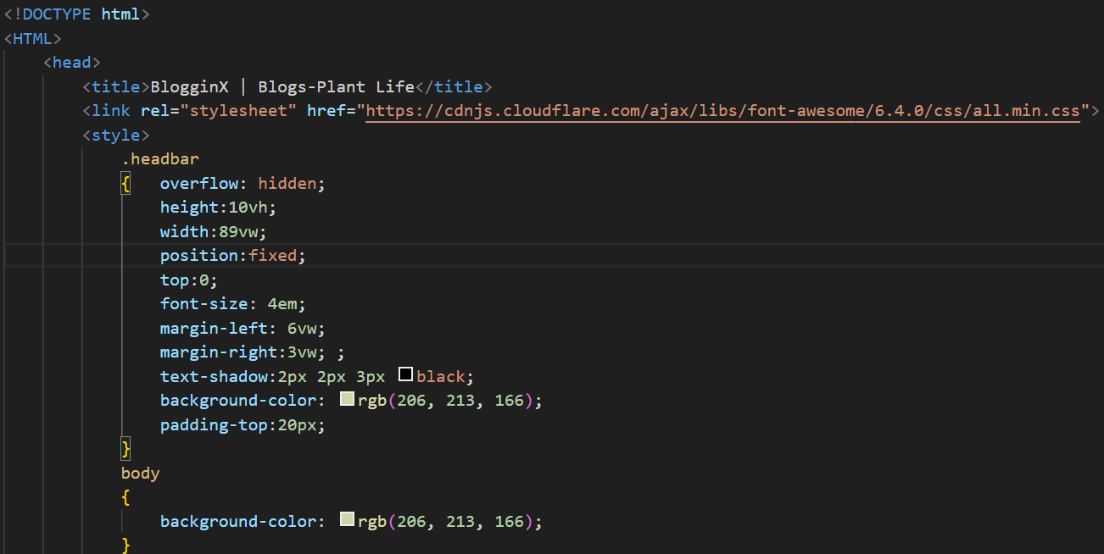

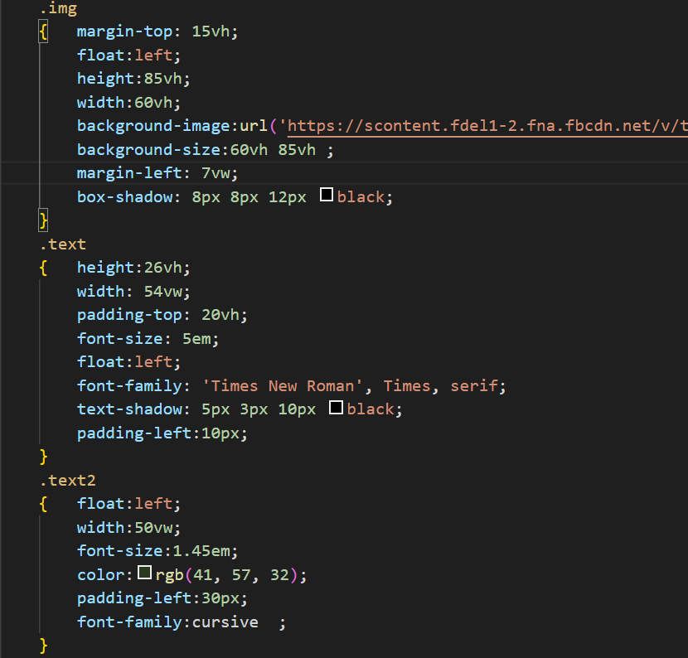

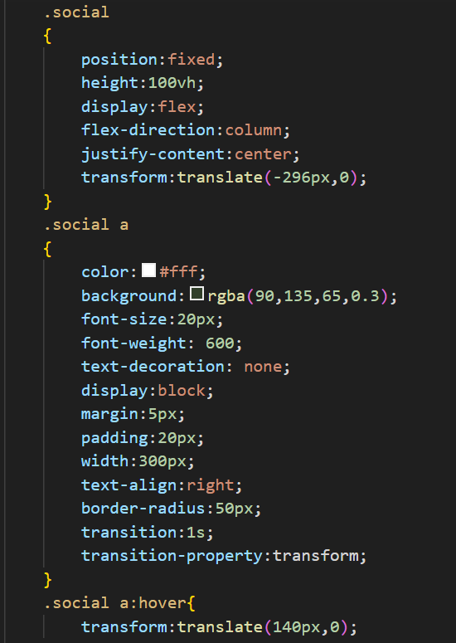

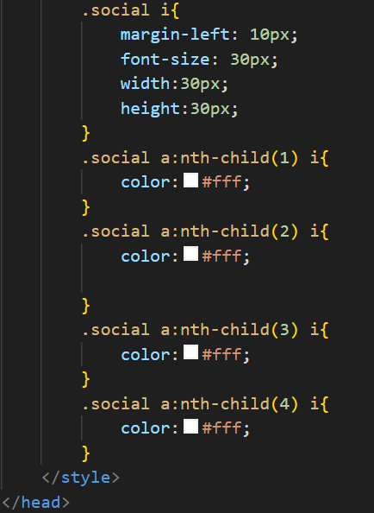

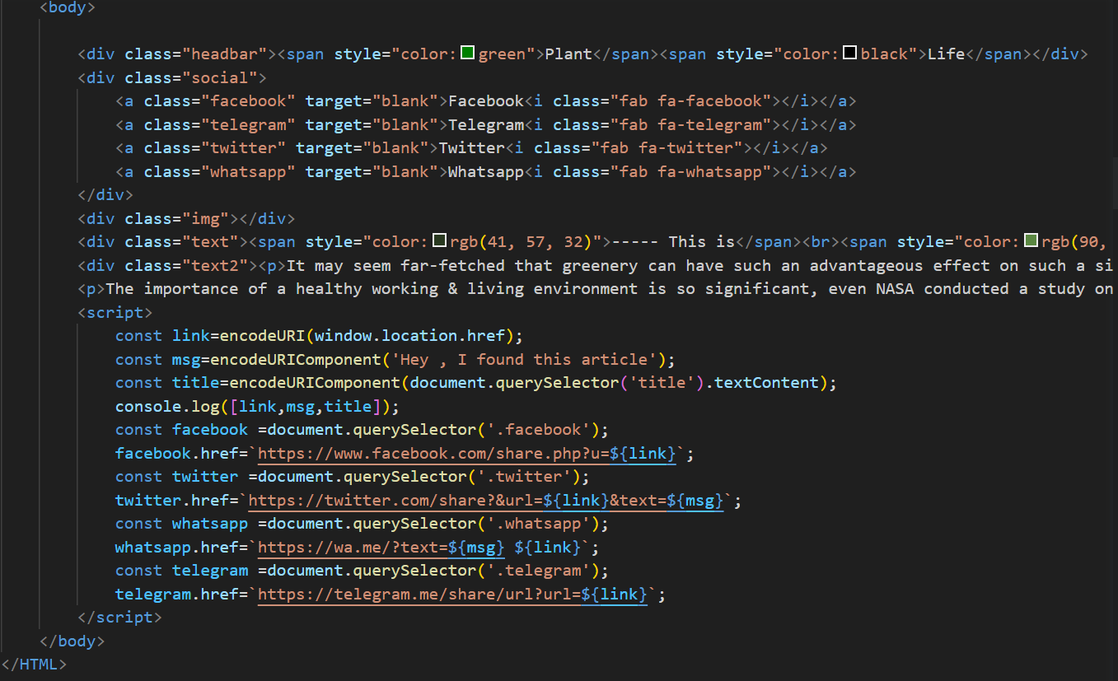

**Contact page –**

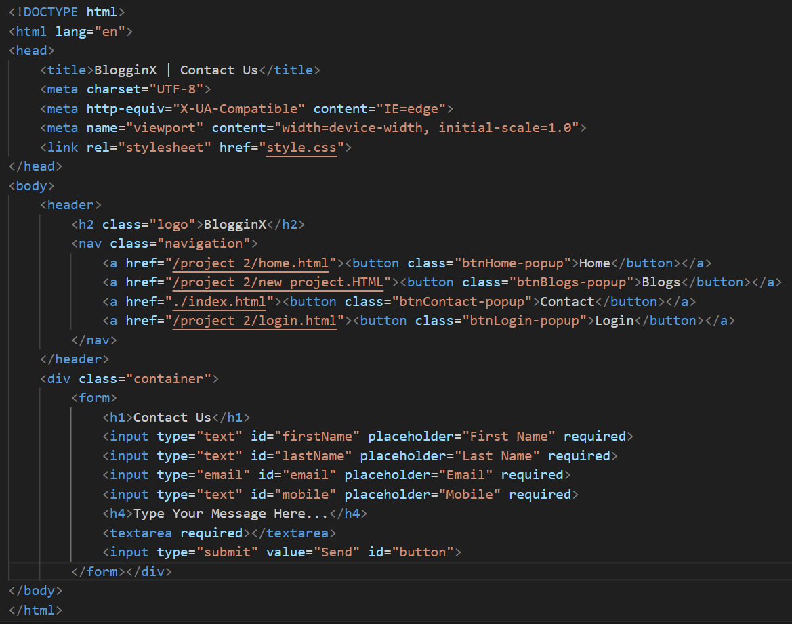

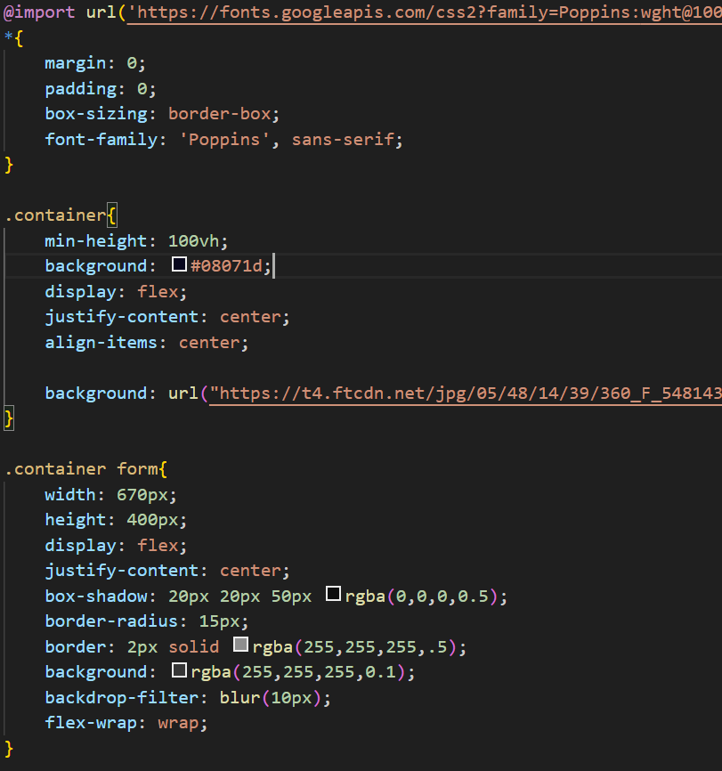

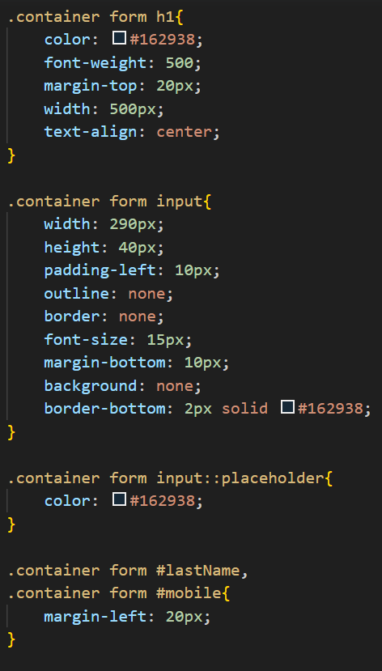

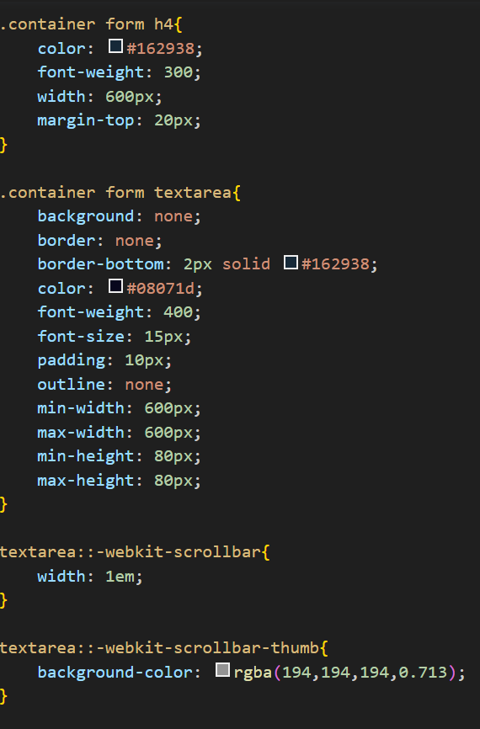

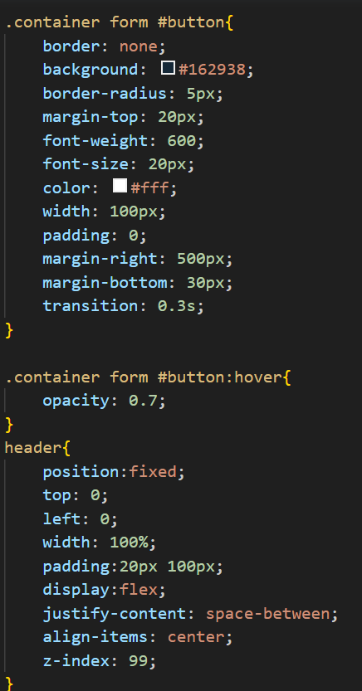

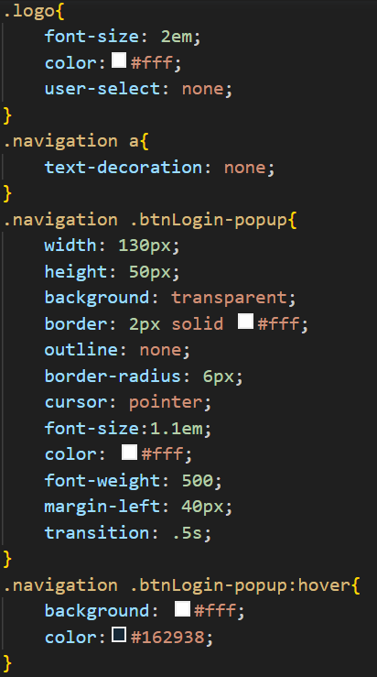

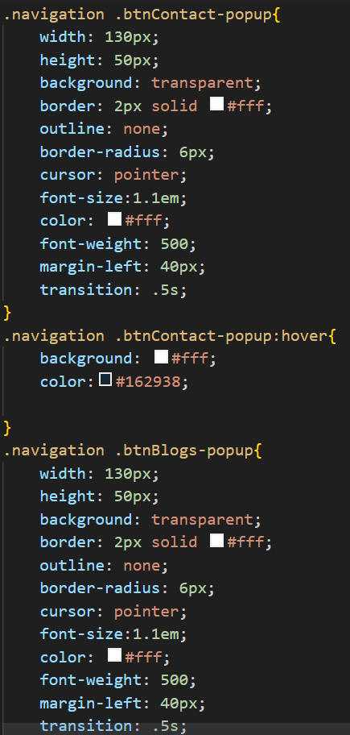

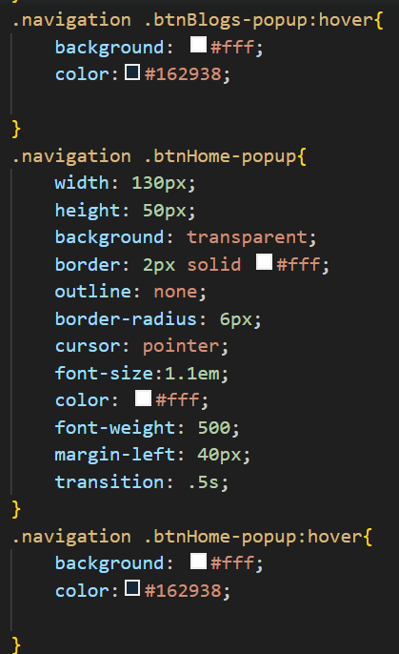

**Login page –**

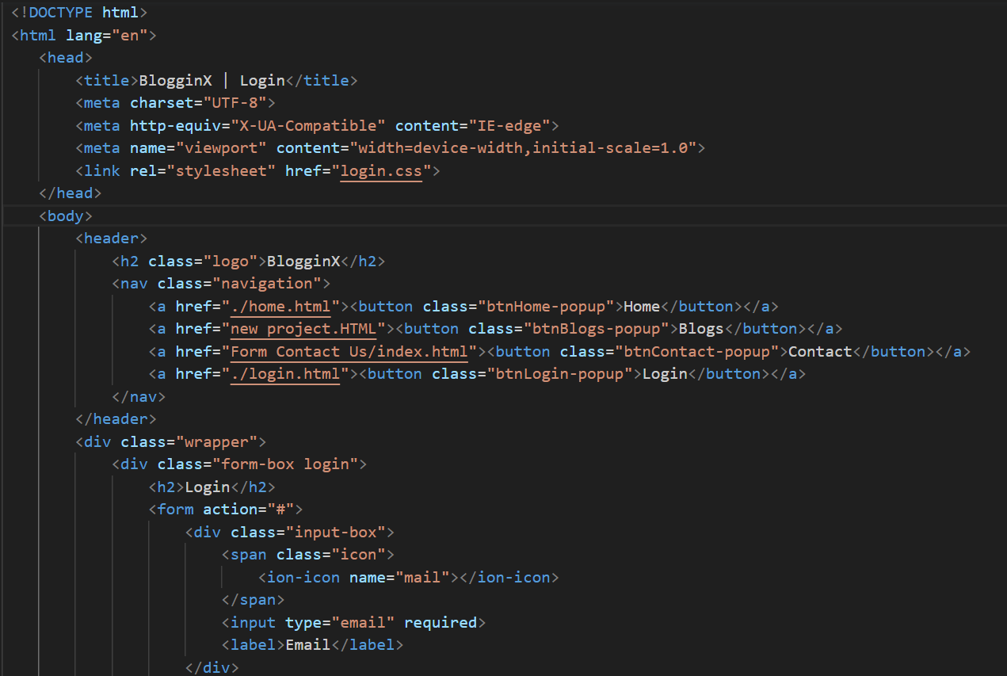

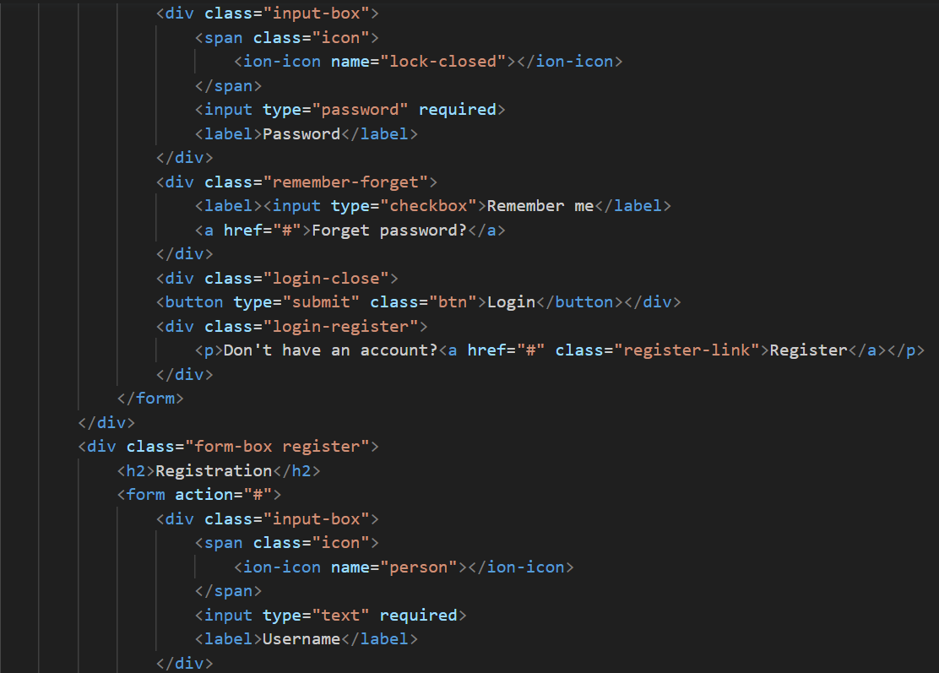

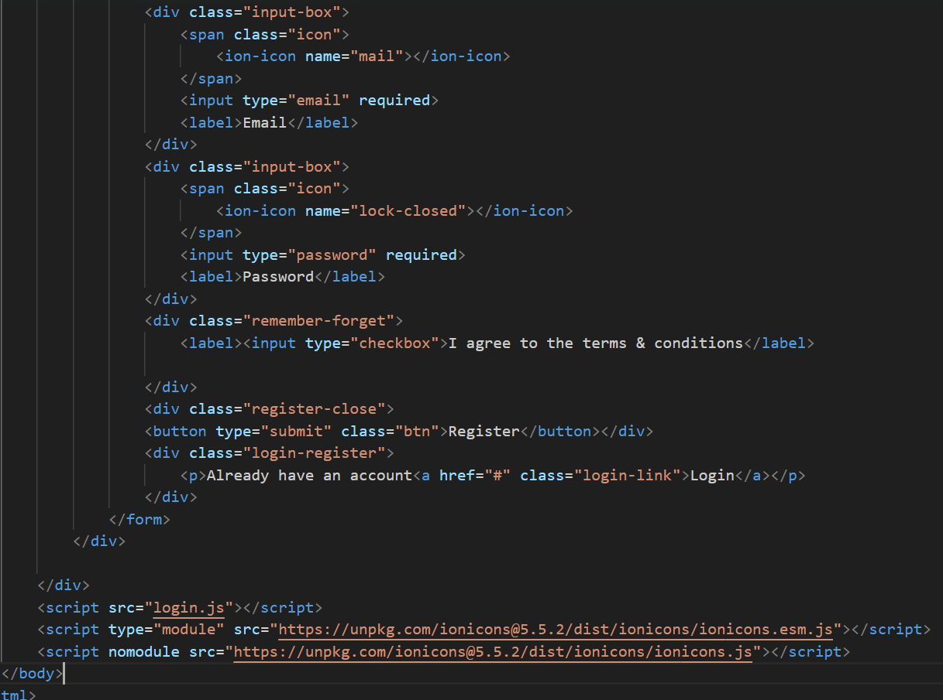

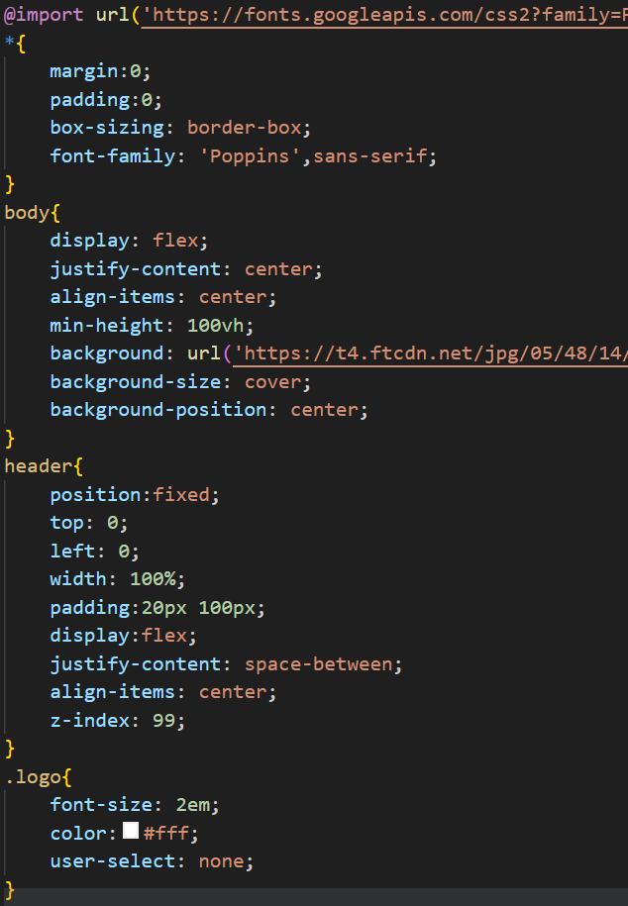

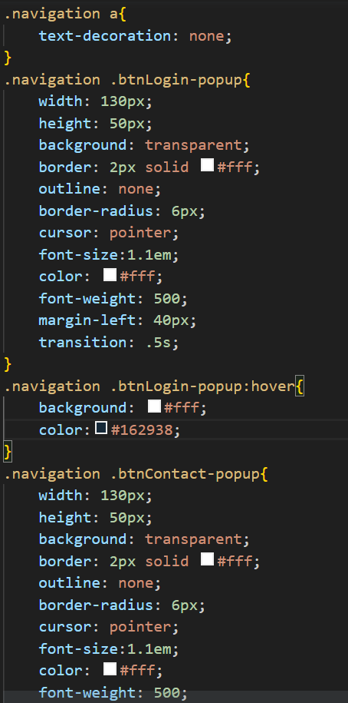

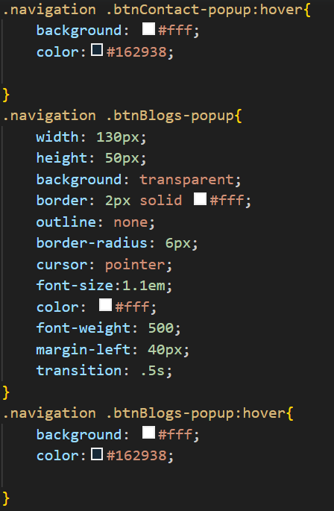

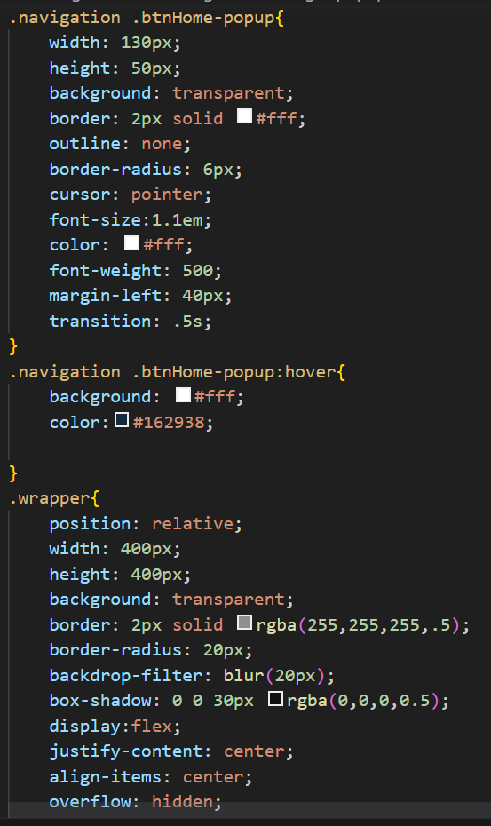

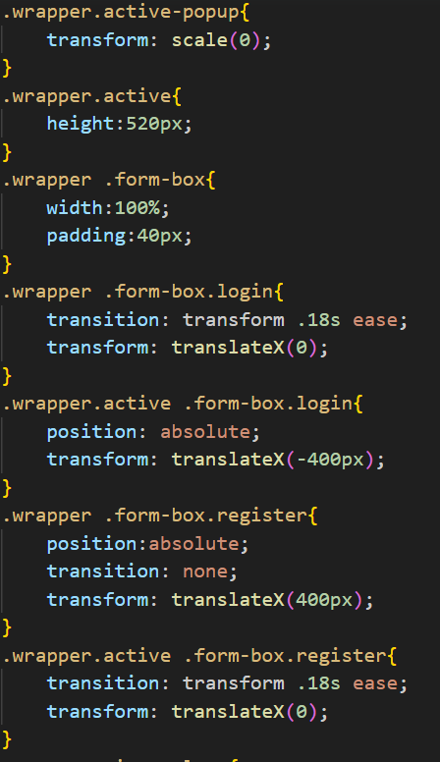

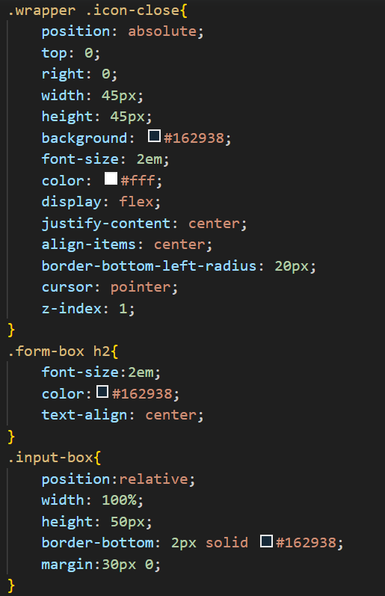

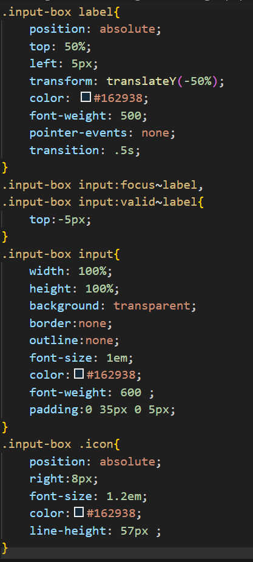



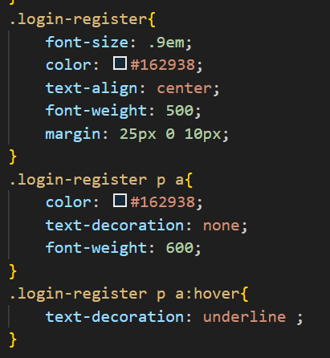

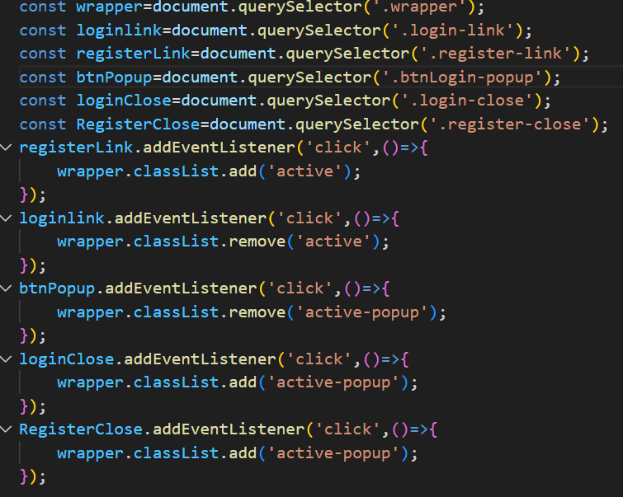

**CONCLUSION**

Social share buttons are a valuable tool for website and content creators to increase their social media presence and promote engagement with their audience. These buttons offer a range of features, including integration with social media platforms, ease of use, customization options, trackability, mobile-friendliness, and the ability to promote social engagement. By incorporating social share buttons into their digital content, website and content creators can increase their online visibility and reach a wider audience, ultimately helping them achieve their marketing and communication goals.

**REFERENCES/LINKS USED**

* [**https://dribbble.com/shots/6211462-Daily-UI-010-Social-Share/attachments/6211462-Daily-UI-010-Social-Share?mode=media**](https://dribbble.com/shots/6211462-Daily-UI-010-Social-Share/attachments/6211462-Daily-UI-010-Social-Share?mode=media)
* [**https://youtu.be/7bVl8zyKr8g**](https://youtu.be/7bVl8zyKr8g)